BHAVANA CK

1BM20CS403

CSE-4A

**PROGRAM 1**

INSURANCE DATABASE

Consider the Insurance database given below. The data types are specified.

PERSON (driver_id: String, name: String, address: String)

CAR (reg_num: String, model: String, year: int)

ACCIDENT (report_num: int, accident_date: date, location: String)

OWNS (driver_id: String, reg_num: String)

PARTICIPATED (driver_id: String,reg_num: String, report_num: int, damage_amount: int)

i) Create the above tables by properly specifying the primary keys and the foreign keys.

ii)Enter at least five tuples for each relation.

iii)Demonstrate how you

a.Update the damage amount to 25000 for the car with a specific reg-num(example 'K A053408') for which the accident report number was 12.

b.Add a new accident to the database.

iv)Find the total number of people who owned cars that involved in accidents in 2008.

v)Find the number of accidents in which cars belonging to a specific model (example )were involved.

CREATE DATABASE Insurance;

USE Insurance;

------ Create the above tables by properly specifying the primary keys and the foreign keys.

CREATE TABLE PERSON

(

DRIVER_ID VARCHAR(15),

NAME VARCHAR(30) NOT NULL,

ADDRESS VARCHAR(30),

PRIMARY KEY(DRIVER_ID)

);

CREATE TABLE CAR(

REG_NUM VARCHAR(15),

MODEL VARCHAR(15),

YEAR INT,

PRIMARY KEY (REG_NUM)

);

CREATE TABLE ACCIDENT(

REPORT_NUM INT,

ACCIDENT_DATE DATE,

LOCATION VARCHAR(30),

PRIMARY KEY (REPORT_NUM)

);

CREATE TABLE OWNS(

DRIVER_ID VARCHAR(15),

REG_NUM VARCHAR(15),

FOREIGN KEY (DRIVER_ID) REFERENCES PERSON(DRIVER_ID),

FOREIGN KEY (REG_NUM) REFERENCES CAR(REG_NUM)

);

CREATE TABLE PARTICIPATED(

DRIVER_ID VARCHAR(15),

REG_NUM VARCHAR(15),

REPORT_NUM INT,

DAMAGE_AMOUNT INT,

FOREIGN KEY (DRIVER_ID) REFERENCES PERSON(DRIVER_ID),

FOREIGN KEY (REG_NUM) REFERENCES CAR(REG_NUM),

FOREIGN KEY (REPORT_NUM) REFERENCES ACCIDENT(REPORT_NUM)

);

------ Enter at least five tuples for each relation.

INSERT INTO PERSON

VALUES("A01","Richard","Srinivas Nagar"),("A02","Pradeep","Rajaji Nagar"),

("A03","Smith","Ashok Nagar"),("A04","Venu","N R Colony"),

("A05","Jhon","Hanumanth Nagar");

SELECT * FROM PERSON;



INSERT INTO CAR

VALUES("KA052250","Indica",1990),("KA031181","Lancer",1957),

("KA095477","Toyota",1998),("KA053408","Honda",2008),

("KA041702","Audi",2005);

SELECT * FROM CAR;



INSERT INTO OWNS

VALUES("A01","KA052250"),("A02","KA053408"),

("A03","KA031181"),("A04","KA095477"),

("A05","KA041702");

SELECT * FROM OWNS;



INSERT INTO ACCIDENT

VALUES(11,'2003-01-01',"Mysore Road"),(12,'2004-02-02',"South end Circle"),

(13,'2003-01-21',"Bull Temple Road"),(14,'2008-02-17',"Mysore Road"),

(15,'2005-03-04',"Kanakpura Road");

SELECT * FROM ACCIDENT;



INSERT INTO PARTICIPATED

VALUES("A01","KA052250",11,10000),("A02","KA053408",12,50000),

("A03","KA031181",13,25000),("A04","KA095477",14,3000),

("A05","KA041702",15,5000);

SELECT * FROM PARTICIPATED;



------ Update the damage amount to 25000 for the car with a specific reg-num(example 'K A053408') for which the accident report number was 12.

UPDATE PARTICIPATED

SET DAMAGE_AMOUNT=25000

WHERE REG_NUM="KA053408";



------ Add a new accident to the database.

INSERT INTO ACCIDENT

VALUES (16,"2009-05-12","Belagavi");

SELECT * FROM ACCIDENT;



------ Find the total number of people who owned cars that involved in accidents in 2008.

SELECT COUNT(ACCIDENT_DATE) AS ACCIDENTS2008 FROM ACCIDENT

WHERE YEAR(ACCIDENT_DATE)=2008;



------- Find the number of accidents in which cars belonging to a specific model ( example )were involved

SELECT COUNT(MODEL) AS INDICA FROM car

WHERE MODEL="Indica";



**PROGRAM 2**

BANKING ENTERPRISE DATABASE

Consider the following database for a banking enterprise.

**Branch** (branch-name: String, branch-city: String, assets: real)

**BankAccount**(accno: int, branch-name: String, balance: real)

**BankCustomer** (customer-name: String, customer-street: String, customer-city: String)

**Depositer**(customer-name: String, accno: int)

**Loan** (loan-number: int, branch-name: String, amount: real)

i. Create the above tables by properly specifying the primary keys and the

foreign keys.

ii. Enter at least five tuples for each relation.

iii. Find all the customers who have at least two accounts at the *Main* branch (ex. SBI_ResidencyRoad).

iv. Find all the customers who have an account at *all* the branches located in a

specific city (Ex. Delhi).

v. Demonstrate how you delete all account tuples at every branch located in

a specific city (Ex. Bombay).

create database sample11;

use sample11;

CREATE TABLE branch

(

branch_name VARCHAR(20),

branch_city VARCHAR(20),

assets REAL,

PRIMARY KEY(branch_name)

);

CREATE TABLE accounts

(

acc_no INT,

branch_name VARCHAR(50),

balance REAL,

PRIMARY KEY(acc_no),

FOREIGN KEY(branch_name) REFERENCES branch(branch_name)

ON UPDATE CASCADE ON DELETE CASCADE

);

CREATE TABLE customer

(

customer_name VARCHAR(20),

customer_street VARCHAR(50),

customer_city VARCHAR(20),

PRIMARY KEY(customer_name)

);

CREATE TABLE depositor

(

customer_name VARCHAR(20),

acc_no INT,

PRIMARY KEY(customer_name, acc_no),

FOREIGN KEY(customer_name) REFERENCES customer(customer_name)

ON UPDATE CASCADE ON DELETE CASCADE,

FOREIGN KEY(acc_no) REFERENCES accounts(acc_no)

ON UPDATE CASCADE ON DELETE CASCADE

);

CREATE TABLE loan

(

loan_number INT,

branch_name VARCHAR(50),

amount REAL,

PRIMARY KEY(loan_number),

FOREIGN KEY(branch_name) REFERENCES branch(branch_name)

ON UPDATE CASCADE ON DELETE CASCADE

);

INSERT INTO branch

VALUES ('SBI_Chamrajpet','Bangalore',50000),('SBI_ResidencyRoad','Bangalore',10000),

('SBI_ShivajiRoad','Bombay',20000),('SBI_ParlimentRoad','Delhi',10000),

('SBI_Jantarmantar','Delhi',20000);

SELECT * FROM branch;

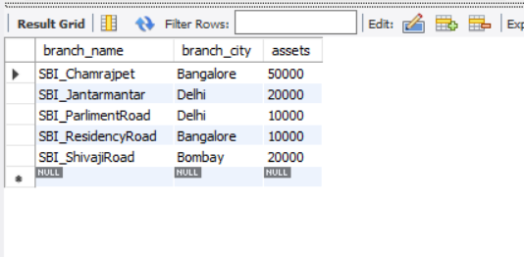

INSERT INTO accounts

VALUES (1,'SBI_Chamrajpet',2000),(2,'SBI_ResidencyRoad',5000),

(3,'SBI_ShivajiRoad',6000),(4,'SBI_ParlimentRoad',9000),

(5,'SBI_Jantarmantar',8000),(6,'SBI_ShivajiRoad',4000),

(8,'SBI_ResidencyRoad',4000),(9,'SBI_ParlimentRoad',3000),

(10,'SBI_ResidencyRoad',5000),(11,'SBI_Jantarmantar',2000);

SELECT * FROM accounts;

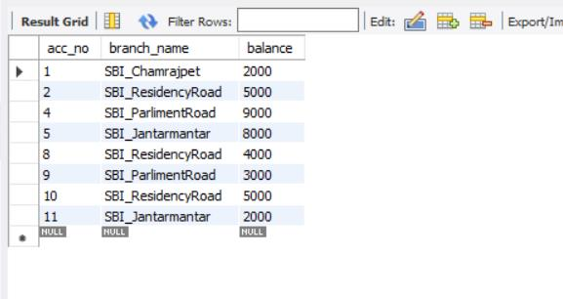

INSERT INTO customer

VALUES('Avinash','Bull_Temple_Road','Bangalore'),('Dinesh','Bannergatta_Road','Bangalore'),

('Mohan','NationalCollege_Road','Bangalore'),('Nikil','Akbar_Road','Delhi'),

('Ravi','Prithviraj_Road','Delhi');

SELECT * FROM customer;

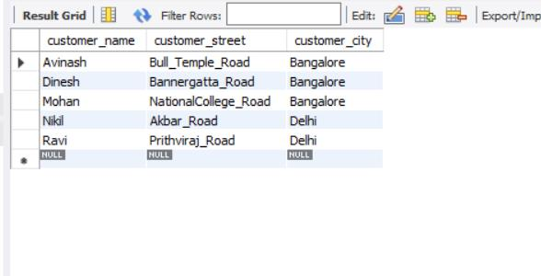

INSERT INTO depositor

VALUES ('Avinash',1),('Dinesh',2),

('Nikil',4),('Ravi',5),

('Avinash',8),('Nikil',9),

('Dinesh',10),('Nikil',11);

SELECT * FROM depositor;

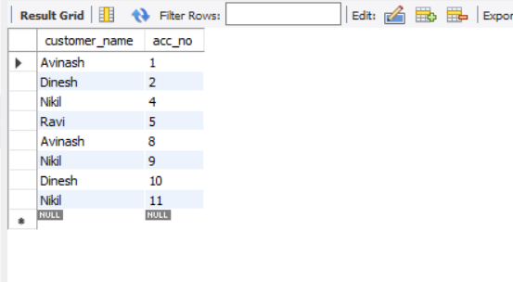

INSERT INTO loan

VALUES (1,'SBI_Chamrajpet',1000),(2,'SBI_ResidencyRoad',2000),

(3,'SBI_ShivajiRoad',3000),(4,'SBI_ParlimentRoad',4000),

(5,'SBI_Jantarmantar',5000);

SELECT * FROM loan;

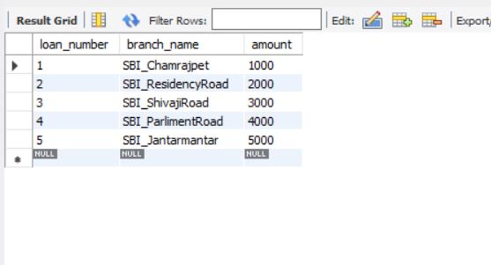

.

------- Find all the customers who have at least two accounts at the *Main* branch (ex. SBI_ResidencyRoad).

SELECT * FROM customer WHERE customer_name IN(SELECT customer_name FROM depositor group by customer_name having COUNT(customer_name)>=2);

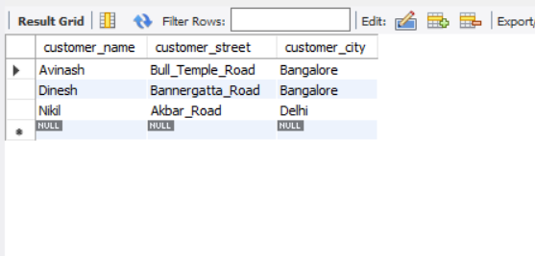

------Find all the customers who have an account at *all* the branches located in a

specific city (Ex. Delhi).

SELECT d.customer_name FROM accounts a, depositor d,branch b WHERE d.acc_no=a.acc_no AND b.branch_name=a.branch_name AND b.branch_city="Delhi" GROUP BY d.customer_name having count(distinct b.branch_name)=(SELECT COUNT(branch_name) FROM branch WHERE branch_city="Delhi");

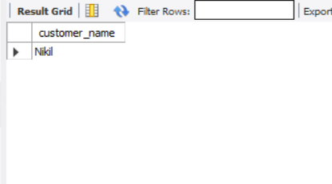

------- Demonstrate how you delete all account tuples at every branch located in

a specific city (Ex. Bombay).

DELETE FROM ACCOUNTS WHERE branch_name IN(SELECT branch_name FROM BRANCH WHERE branch_city='Bombay');



**PROGRAM 3**

SUPPLIER DATABASE

Consider the following schema:

SUPPLIERS(sid: integer, sname: string, address: string)

PARTS(pid: integer, pname: string, color: string)

CATALOG(sid: integer, pid: integer, cost: real)

The Catalog relation lists the prices charged for parts by Suppliers.

Write the following queries in SQL:

1. Find the pnames of parts for which there is some supplier.
2. Find the snames of suppliers who supply every part.
3. Find the snames of suppliers who supply every red part.
4. Find the pnames of parts supplied by Acme Widget Suppliers and by no one else.
5. Find the sids of suppliers who charge more for some part than the average cost of that part (averaged over all the suppliers who supply that part).
6. For each part, find the sname of the supplier who charges the most for that part.

create database supplier;

use supplier;

create table suppliers(

sid int not null,

sname varchar(20) not null,

address varchar(20) not null,

primary key(sid)

);

create table parts(

pid int not null,

pname varchar(20) not null,

color varchar(10) not null,

primary key(pid)

);

create table catalog(

sid int not null,

pid int not null,

cost real not null,

primary key(sid,pid),

foreign key(sid)references suppliers(sid),

foreign key(pid)references parts(pid)

);

insert into suppliers

values(10001,"Acme Widget","Bangalore"),(10002,"Johns","Kolkata"),

(10003,"Vimal","Mumbai"),(10004,"Reliance","Delhi");



insert into parts

values (20001,"Book","Red"),(20002,"Pen","Red"),

(20003,"Pencil","Green"),(20004,"Mobile","Green"),

(20005,"Charger","Black");



insert into catalog

values(10001,20001,10),(10001,20002,10),

(10001,20003,30),(10001,20004,10),

(10001,20005,10),(10002,20001,10),

(10002,20002,20),(10003,20003,30),

(10004,20003,40);



-----Find the pnames of parts for which there is some supplier.

select distinct pname from parts,catalog

where catalog.pid= parts.pid and sid is not null;



-----Find the snames of suppliers who supply every part.

select suppliers.sname,catalog.sid from suppliers,catalog

where suppliers.sid = catalog.sid

group by suppliers.sname

having count(catalog.sid)=(select count(pid) from parts);



----Find the snames of suppliers who supply every red part.

select distinct s.sname from suppliers s,catalog c

where s.sid=c.sid and c.pid in(select pid from parts where color ="Red");



-----Find the pnames of parts supplied by Acme Widget Suppliers and by no one else.

select pname from parts ,catalog

where parts.pid=catalog.pid and sid in (select sid from suppliers where sname ="Acme Widget");



-----Find the sids of suppliers who charge more for some part than the average cost of that part (averaged over all the suppliers who supply that part).

select c.sid from catalog c

where c.cost>(select avg(cost)from catalog where pid = c.pid);



----For each part, find the sname of the supplier who charges the most for that part.

select c.pid,s.sname from suppliers s,catalog c

where s.sid =c.sid and c.cost =(select max(cost) from catalog where pid =c.pid);



PROGRAM 4

STUDENT FACULTY DATABASE

Consider the following database for student enrollment for course :

STUDENT(snum : integer, sname : string, major: string, lvl : string, age: integer)

CLASS(cname: string, meets at: time, room: string, fid: integer)

ENROLLED(snum: integer, cname: string)

FACULTY(fid: integer, fname: string, deptid: integer)

The meaning of these relations is straightforward; for example, Enrolled has one record per student-class pair such that the student is enrolled in the class. Level(lvl) is a two character code with 4 different values (example: Junior: JR etc)

Write the following queries in SQL. No duplicates should be printed in any of the answers.

1. Find the names of all Juniors (level = JR) who are enrolled in a class taught by
2. Find the names of all classes that either meet in room R128 or have five or more Students enrolled.
3. Find the names of all students who are enrolled in two classes that meet at the same time.
4. Find the names of faculty members who teach in every room in which some class is taught.
5. Find the names of faculty members for whom the combined enrollment of the courses that they teach is less than five.
6. Find the names of students who are not enrolled in any class.
7. For each age value that appears in Students, find the level value that appears most often. For example, if there are more FR level students aged 18 than SR, JR, or SO students aged 18, you should print the pair (18, FR).

create database studentfaculty;

use studentfaculty;

create table student(

snum int not null,

sname varchar(20) not null,

major varchar(2) not null,

lvl varchar(2) not null,

age int not null,

primary key (snum)

);

create table faculty(

fid int not null,

fname varchar(20) not null,

deptid int not null,

primary key(fid)

);

create table class(

cname varchar(20) not null,

meetsat datetime not null,

room varchar(4) not null,

fid int not null,

primary key (cname),

foreign key(fid)references faculty(fid)

);

create table enrolled(

snum int not null,

cname varchar(20) not null,

primary key(snum,cname),

foreign key(snum)references student(snum),

foreign key(cname) references class(cname )

);

insert into student

values (1,"Jhon","CS","Sr",19) ,(2,"Smith","CS","Jr",20),

(3,"Jacob","CV","Sr",20),(4,"Tom","CS","Jr",20),

(5,"Rahul","CS","Jr",20),(6,"Ria","CS","Sr",21);



insert into faculty

values(11,"Harish",1000),(12,"MV",1000),

(13,"Mira",1001),(14,"Shiva",1002),

(15,"Nupur",1000);



insert into class

values("class 1","2015-11-12 10:15:16","R1",14),

("class 10","2015-11-12 10:15:16","R128",14),

("class 2","2015-11-12 10:15:20","R2",12),

("class 3","2015-11-12 10:15:25","R3",11),

("class 4","2015-11-12 20:15:20","R4",14),

("class 5","2015-11-12 20:15:20","R3",15),

("class 6","2015-11-12 13:20:20","R2",14),

("class 7","2015-11-12 10:10:10","R3",14);



insert into enrolled

values(1,"class 1"),(2,"class 1"),

(3,"class 3"),(4,"class 3"),

(5,"class 4");



------ Find the names of all Juniors (level = JR) who are enrolled in a class taught by

select s.sname from student s,enrolled e,class c

where s.snum=e.snum and c.cname = e.cname and c.fid =(select fid from faculty

where fname ="Harish")and s.lvl="Jr";



------ Find the names of all classes that either meet in room R128 or have five or more Students enrolled.

select c.cname from class c

where c.room = "R128"

or c.cname in(select e.cname from enrolled e group by e.cname having count(*)>=5);



------ Find the names of all students who are enrolled in two classes that meet at the same time.

select distinct s.sname from student s

where s.snum in(select e1.snum from enrolled e1,enrolled e2,class c1,class c2

where e1.snum=e2.snum and e1.cname<>e2.cname and e1.cname = c1.cname

and e2.cname=c2.cname and c1.meetsat=c2.meetsat);



------ Find the names of faculty members who teach in every room in which some class is taught.

select f.fname,c.fid from faculty f,class c

where f.fid = c.fid

group by c.fid

having count(c.fid)=(select count(distinct room) from class);



------ Find the names of faculty members for whom the combined enrollment of the courses that they teach is less than five.

select distinct fname from faculty f

where 5>(select count(e.snum)from enrolled e,class c

where c.cname = e.cname and c.fid = f.fid);



------ Find the names of students who are not enrolled in any class.

select s.sname from student s

where snum not in(select snum from enrolled);



------ For each age value that appears in Students, find the level value that appears most often. For example, if there are more FR level students aged 18 than SR, JR, or SO students aged 18, you should print the pair (18, FR).

select s.age,s.lvl from student s

group by s.age having s.lvl in(select s1.lvl from student s1

where s1.age = s.age group by s1.age having count(*)>=all(select s2.lvl from student s2

where s2.age = s1.age group by s2.age));



PROGRAM 5

AIRLINE FLIGHT DATABASE

Consider the following database that keeps track of airline flight information:

FLIGHTS(flno: integer, from: string, to: string, distance: integer, departs: time, arrives: time, price: integer)

AIRCRAFT(aid: integer, aname: string, cruisingrange: integer)

CERTIFIED(eid: integer, aid: integer)

EMPLOYEES(eid: integer, ename: string, salary: integer)

Note that the Employees relation describes pilots and other kinds of employees as well; Every pilot is certified for some aircraft, and only pilots are certified to fly.

Write each of the following queries in SQL.

1. Find the names of aircraft such that all pilots certified to operate them have salaries more than Rs.80,000.
2. For each pilot who is certified for more than three aircrafts, find the eid and the maximum cruisingrange of the aircraft for which she or he is certified.
3. Find the names of pilots whose salary is less than the price of the cheapest route from Bengaluru to Frankfurt.
4. For all aircraft with cruisingrange over 1000 Kms, find the name of the aircraft and the average salary of all pilots certified for this aircraft.
5. Find the names of pilots certified for some Boeing aircraft.
6. Find the aids of all aircraft that can be used on routes from Bengaluru to New Delhi.
7. A customer wants to travel from Madison to New York with no more than two changes of flight. List the choice of departure times from Madison if the customer wants to arrive in New York by 6 p.m.

create database airlines;

use airlines;

create table flights(

flno int not null,

from_loc varchar(20) not null,

to_loc varchar(20) not null,

distance int not null,

departs time not null,

arrives time not null,

price int not null,

primary key(flno)

);

create table aircraft(

aid int not null,

aname varchar(20) not null,

cruisingrange int not null,

primary key(aid)

);

create table employees(

eid int not null,

ename varchar(20) not null,

salary int not null,

primary key(eid)

);

create table certified(

eid int not null,

aid int not null,

primary key(eid,aid),

foreign key(eid)references employees(eid),

foreign key(aid)references aircraft(aid)

);

insert into flights

values(101,"Bangalore","Delhi",2500,"07:15:31","12:15:31",5000),

(102,"Bangalore","Lucknow",3000,"07:15:31","11:15:31",6000),

(103,"Lucknow","Delhi",500,"12:15:31","17:15:31",3000),

(107,"Bangalore","Frankfurt",8000,"07:15:31","22:15:31",60000),

(104,"Bangalore","Frankfurt",8500,"07:15:31","23:15:31",75000),

(105,"Kolkata","Delhi",3400,"07:15:31","09:15:31",7000),

(106,"Delhi","Kolkata",3400,"12:15:35","14:20:00",7000);



insert into aircraft

values (101,"747",3000),(102,"Boeing",900),

(103,"647",800),(104,"Dreamliner",10000),

(105,"Boeing",3500),(106,"707",1500),

(107,"Dream",12000);



insert into employees

values(701,'A',50000),(702,'B',100000),

(703,'C',150000),(704,'D',90000),

(705,'E',40000),(706,'F',60000),

(707,'G',90000);



insert into certified

values(701,101),(701,102),

(701,106),(701,105),

(702,104),(703,104),

(704,104),(702,107),

(703,107),(704,107),

(702,101),(703,105),

(704,105),(705,103);



----- Find the names of aircraft such that all pilots certified to operate them have salaries more than Rs.80,000.

select distinct a.aname from aircraft a,employees e,certified c

where a.aid = c.aid and e.eid = c.eid and e.salary>80000;



----- For each pilot who is certified for more than three aircrafts, find the eid and the maximum cruisingrange of the aircraft for which she or he is certified.

select e.eid ,e.ename,max(a.cruisingrange)from employees e,certified c,aircraft a

where e.eid = c.eid and a.aid = c.aid group by e.ename having count(c.aid)>3;



----- Find the names of pilots whose salary is less than the price of the cheapest route from Bengaluru to Frankfurt.

select e.ename from employees e

where salary<(select min(price) from flights

where from_loc = "Bangalore" and to_loc = "Frankfurt");



----- For all aircraft with cruisingrange over 1000 Kms, find the name of the aircraft and the average salary of all pilots certified for this aircraft.

select a.aname,a.cruisingrange,avg(e.salary)

from aircraft a,employees e,certified c

where c.eid = e.eid and c.aid = a.aid

group by a.aname having a.cruisingrange>1000;



----- Find the names of pilots certified for some Boeing aircraft.

select distinct e.ename from employees e,certified c,aircraft a

where e.eid = c.eid and a.aid = c.aid and aname like "Boeing";



----- Find the aids of all aircraft that can be used on routes from Bengaluru to New Delhi.

select a.aid from aircraft a

where a.cruisingrange>=(select distance from flights

where from_loc="Bangalore" and to_loc="Delhi");



----- A customer wants to travel from Madison to New York with no more than two changes of flight. List the choice of departure times from Madison if the customer wants to arrive in New York by 6 p.m.

select f.from_loc,f.to_loc,f.arrives from flights f

where (f.from_loc ="Bangalore" and f.to_loc =(select from_loc from flights

where to_loc = "Kolkata")) or f.to_loc="Kolkata";

